Beginners Feltmaking workshop requirements
Time: 10am – 4pm on Saturday 14 August 2021, setup from 9.30am
Location: Textile Works, 19/70 Maclaurin Crescent, Chifley ACT
(follow the signs inside the building, parking is free)
Tutor: Lynn Petersen

Materials All wool and other materials will be provided for this workshop.

Felting equipment. Please bring:
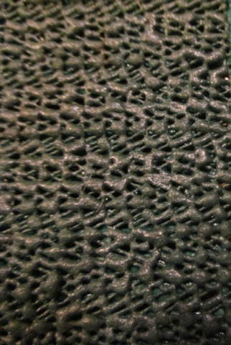
- 2 x old towels (essential) and a large absorbent chamois (optional)
- 1 x plastic supermarket bag and a plastic vegetable bag (ie very flimsy plastic)
- Piece of bubble wrap about 2m x minimum 30cm size
- 1 x grip mat approximately 2m x min 50cm (flexible plastic matting available from hardware shops, often sold as drawer liners or to stop rugs slipping, see photo on right)
- 2 x thin plastic sheeting approximately 2.5m x 1m (eg from a cheap plastic painters dropsheet)
- 1 x small amount of dishwashing detergent and small bar of mild soap
- 1 x plastic bucket
- 1 x plastic container (eg ice cream container)
- ball brauser or other way of sprinkling water (a plastic bottle with holes drilled in the lid is OK as long as the holes are small so you don’t make a flood, or an empty plastic sauce bottle with an adjustable flow nozzle/lid)
- scissors to cut fabric
- needle and thread
- notebook and pen
- camera (optional)

Food
Bring your own lunch. Tea and coffee will be provided.

More information
Contact Workshop Coordinator on 0403 243 787 or email workshops@canfelt.org.au

